Regulations:
A18

H.T No

Sreenidhi Institute of Science and Technology
(An Autonomous Institution)
Code No: 7K201 Date: 18-June-2019 (FN)

B.Tech I-Year II-Semester External Examination, June-2019 (Regular)
ENGINEERING MECHANICS FOR CIVIL ENGINEERING (CIVIL)

Time: 3 Hours Max.Marks:70

Note: a) No additional answer sheets will be provided.
b) All sub-parts of a question must be answered at one place only, otherwise it will not be valued.
c) Missing data can be assumed suitably.

Part - A Max.Marks:20

Answer all QUESTIONS.

1. | Explain about parallelogram law. | [2M]
2. | Discuss the friction and limiting friction. | [2M]
3. | Demonstrate the polar moment of inertia and center of gravity. | [2M]
4. | Explain about principle of work done and potential energy | [2M]
5. | State and explain about Rectilinear motion and curvilinear motion. | [2M]
6. | Discuss about conservative force and non-conservative force. | [2M]
7. | Distinguish between method of joints and method of sections. | [2M]
8. | Explain about principle virtual work and potential energy. | [2M]
9. | A particle of mass 10Kg falls vertically from a height of 100m from the ground. What is the change in potential energy when it has reached a height of 50 m. | [2M]
10. | The resultant of two forces acting at an angle of 60⁰ is 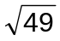. If they act at right angle their resultant would be 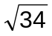. find the magnitude of the forces. | [2M]
Part – B Max.Marks:50
ANSWER ANY FIVE QUESTIONS. EACH QUESTION CARRIES 10 MARKS.

11. | a) | Determine the resultant of concurrent forces shown in the figure.  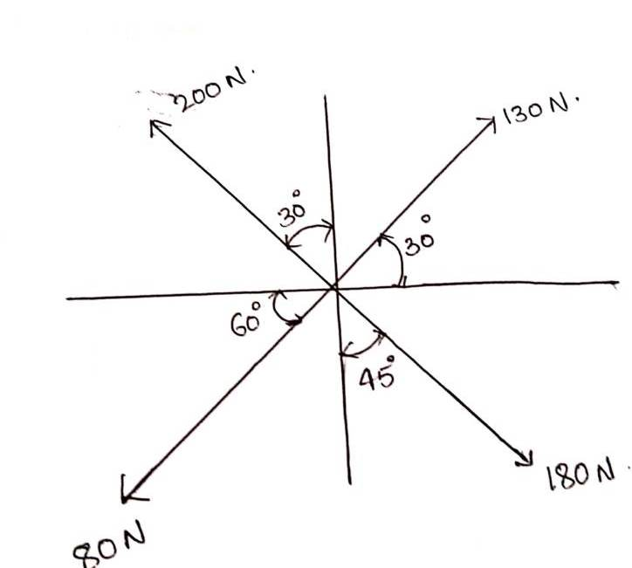 | [5M]
 | b) | The figure shows a 10 kg lamp supported by two cables AB and AC. Find the tension in each cable.  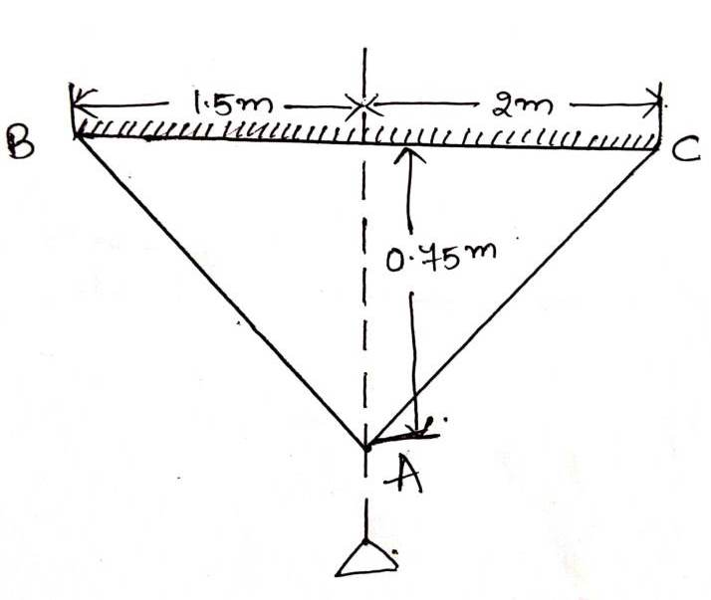 | [5M]
12. | a) | Block A weighing 1000N is to be raised by means of a 15º wedge B weighing 500N as shown in figure. Assuming coefficient of friction 0.2. Determine the minimum Horizontal force P should apply to raise the block.  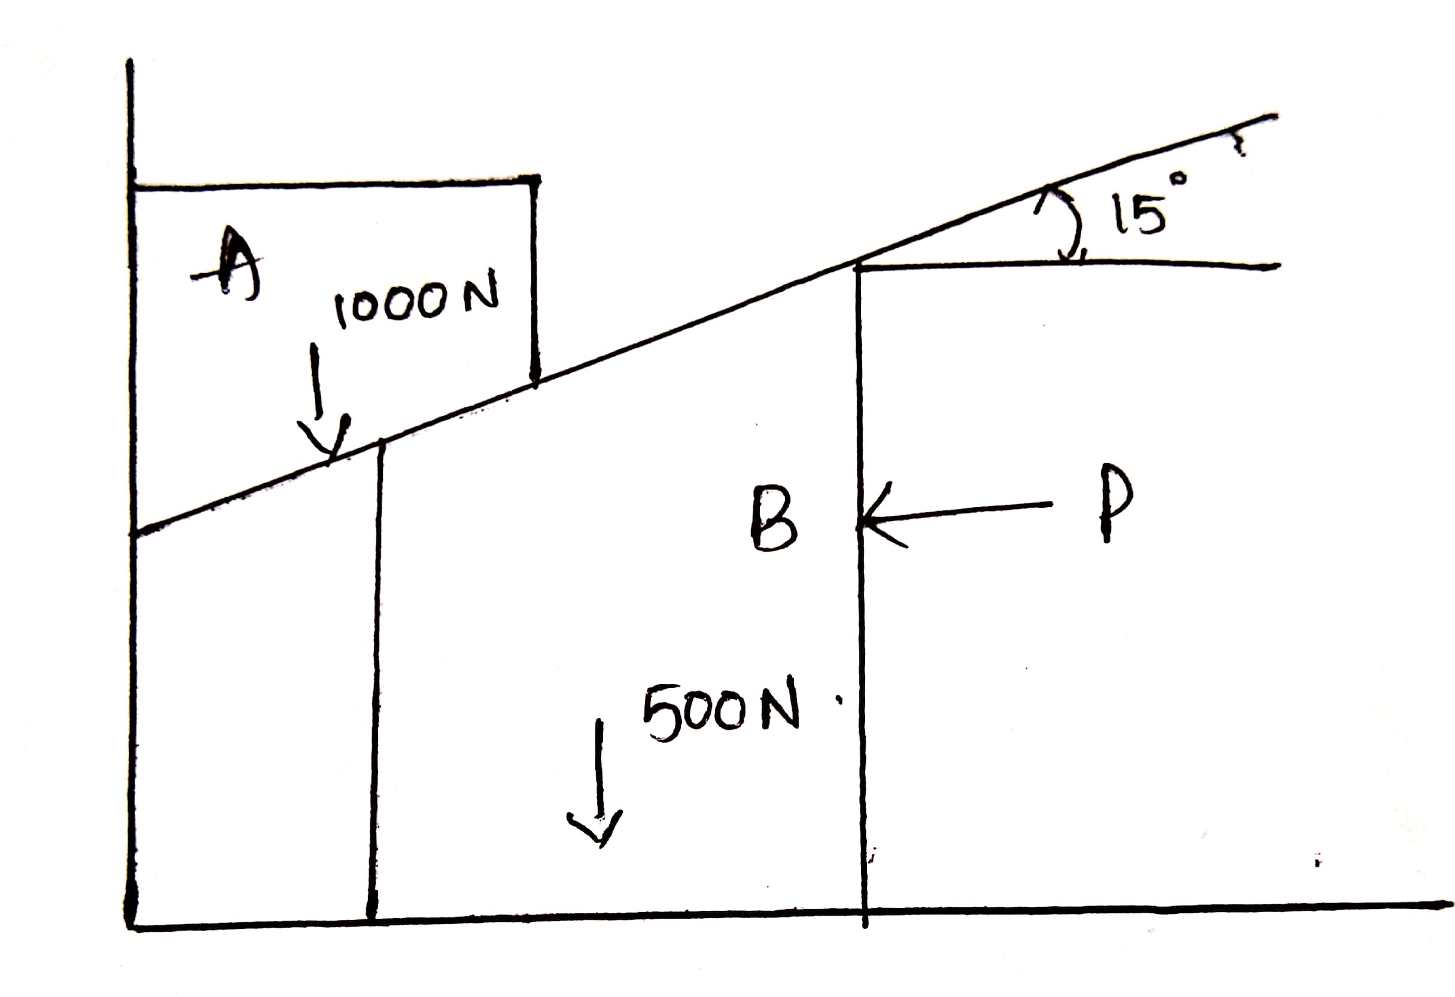 | [5M]
 | b) | Determine the member reactions of truss for BD, BE and CE joints as shown in figure.  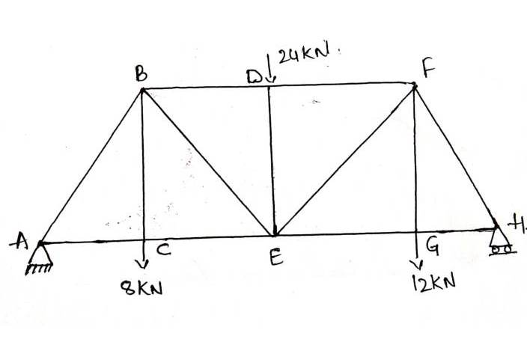 | [5M]
13. | a) | Find out center of gravity of given section as shown in figure.  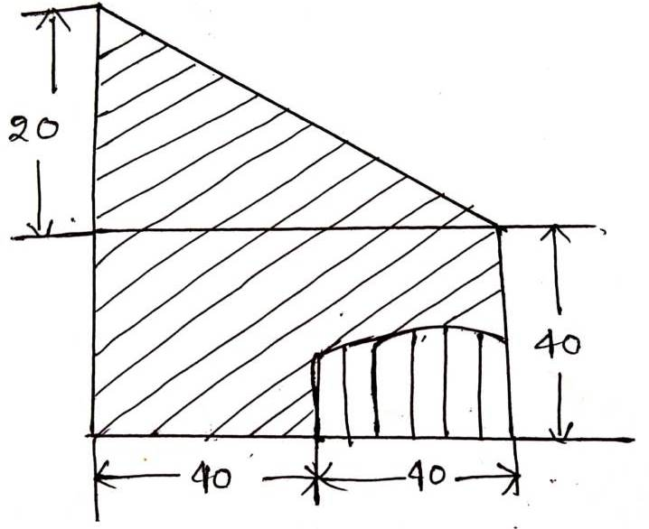 | [5M]
 | b) | Calculate the moment of inertia area under the curve as shown in figure.  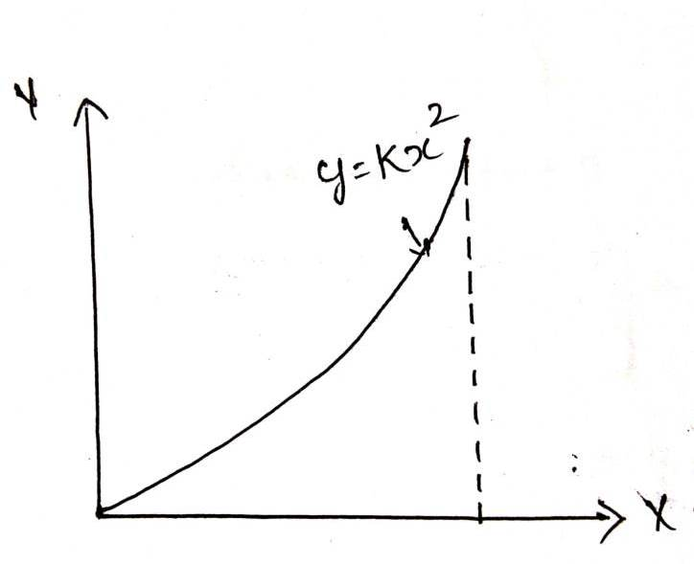 | [5M]
14. | a) | Two beams AB and CD are arranged and supported as shown in figure . Find the reaction Re if a load w of 1000N act down word.  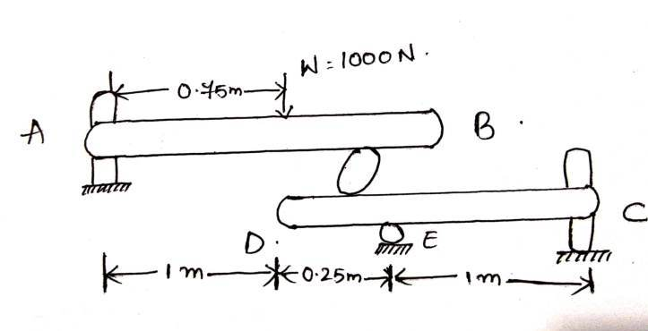 | [5M]
 | b) | Two uniform rods each of length ‘l’ and weight ‘W’ are connected as shown in figure. Using method of virtual work determine Ø₁ and Ø₂ corresponding to equilibrium.  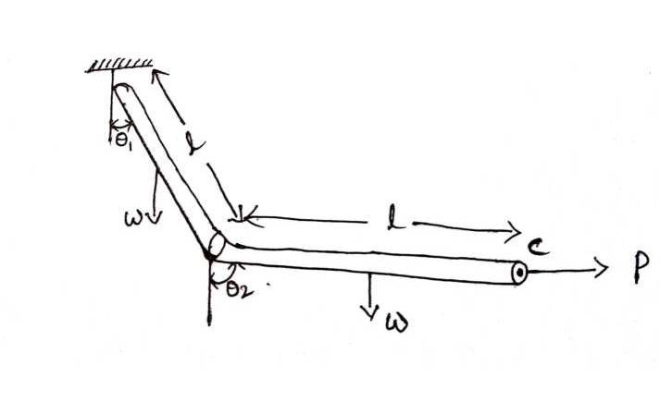 | [5M]
15. | a) | An open platform elevator is moving down a mine shaft with an acceleration 0.5 m/s^{2.} After the elevator has travelled 25m (from the top shaft) a stone dropped from the shaft determine.  i) the time taken the stone to hit the elevator.  ii) The distance travelled by the elevator at the time of impact. | [5M]
 | b) | A passenger train passes certain station at 60km/hr and covers a distance 12km with this speed and stops at next station 15km from the first with uniform retardation as shown in figure. A local train starting from first station covers same distance in double the time and next station. Determine the max speed of local train which covers a part of distance with uniform acceleration and rest with uniform retardation.  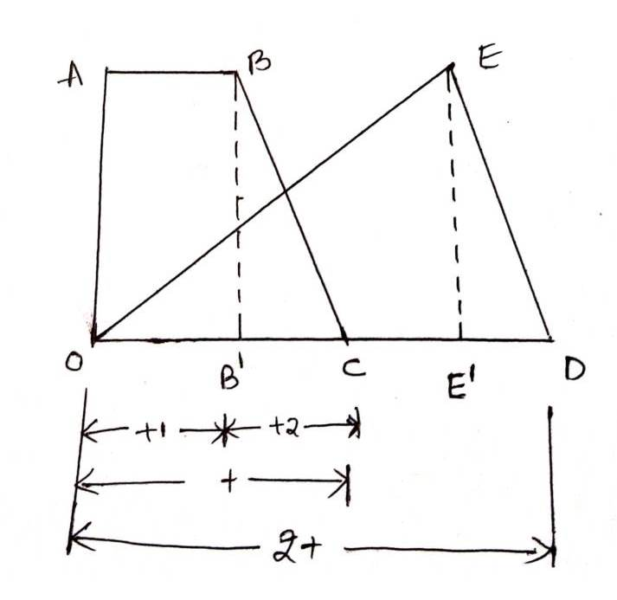 | [5M]
16. | a) | A projectile if fired with a velocity 500m/s with an elevation of 30º. Find the velocity and direction of projectile after 30sec of its firing also find out range of projectile. | [5M]
 | b) | Two blocks of mass M1=5kg and M2= 10Kg are placed on two inclined planes of elevation Ø1=30º and Ø2=60º are connected by a string as shown in figure and coefficient of friction 0.33. Find out acceleration of masses.  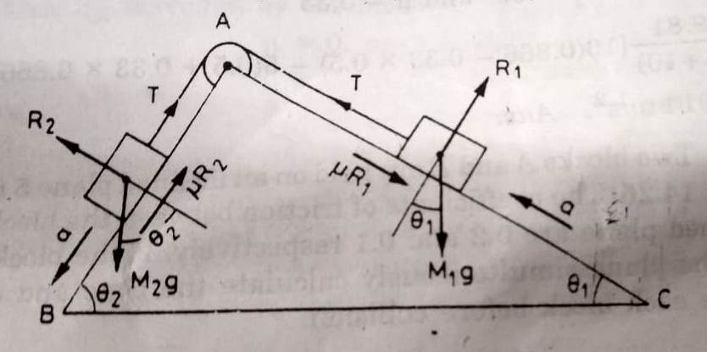 | [5M]
17. | a) | A uniform wheel of 60 cm diameter and weighing 1000N rests against a rectangular block 15 cm lying on a horizontal plane as shown in figure. It is to be pulled over the block by a horizontal force P applied at the end. Find the force P when the wheel is just about roll over the block.  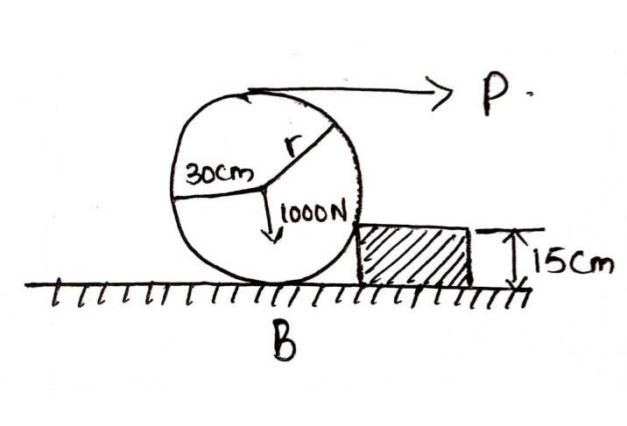 | [5M]
 | b) | Find out moment of inertia of given C section as shown in figure  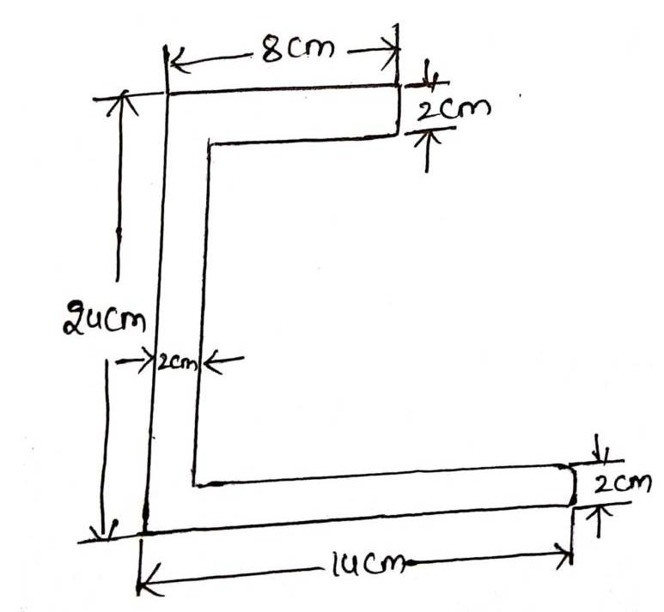 | [5M]
18. | a) | Motion of particle is given as x= t³-3t²-9t+12. Determine the position, time and acceleration of particle when the velocity | [3M]
 | b) | A stone dropped from the top of a tower 50m high. At the same time another stone is thrown up from the foot of tower with velocity 25m/s. At what distance from the top and after how much time the two stones cross each other. | [4M]
 | c) | Three spherical balls of mass 2kg, 6kg and 12 kg are moving in the same direction with velocity 12 m/s, 4m/s and 2m/s. if the ball of mass 2kg impinges which the ball of mass 6kgs which in turn impinges which the ball of mass 12 kg prove that balls of masses 2kg and 6kg will be brought to rests by the impact. Assume balls are perfectly elastic. | [3M]
-- 00 -- 00 –

